Respondus: Creating a Quiz

# Creating Quiz Question Files

Respondus works by importing text or Word files containing the quiz questions and converting them to the proper format. These files must be in a certain format to work properly with Respondus.

Follow the instructions in the Respondus Formatting Guidelines document to create a properly-formatted file. Save the file once all quiz questions are entered and formatted correctly.

# Using Respondus to Create a Quiz

1. Open the Respondus 4.0 Campus-Wide application on your laptop.

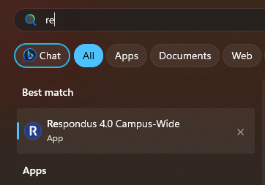

1. If prompted, click **OK** to check for updates. It is important to ensure that Respondus remains updated in order for it to work properly.
2. Click the **Import Questions** link on the Respondus main screen.

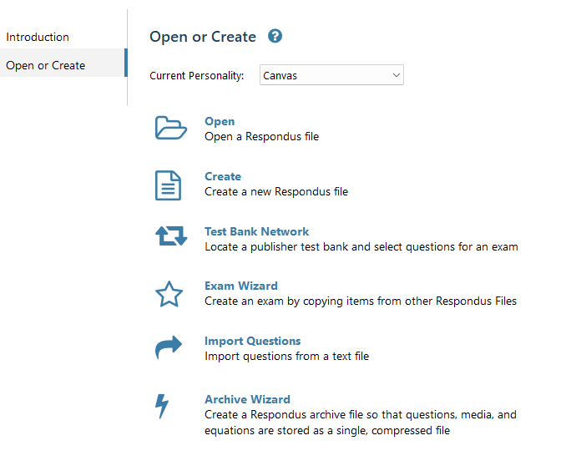

The *Import Questions* dialog box appears.

1. Click the **Browse** button to the right of the **File name** field. Navigate to the location where the text file is saved, select it, and click **Open**.
2. Locate the **Create a new document** radio button and enter a name for the new file.
3. Check the **Use “stem” plus…** box and enter “<file name entered in the previous step> - “.
4. Click the **Preview** button and look over the questions in the bottom of the window to ensure they appear correct.
5. Click **Finish**.
6. Click the **Preview + Publish** link at the top of the window and then click the **Publish** option.

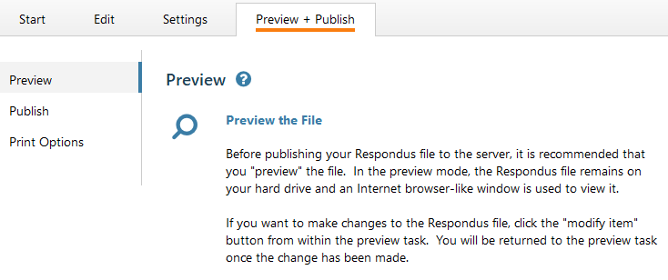

1. Click the **Publish Wizard** link.

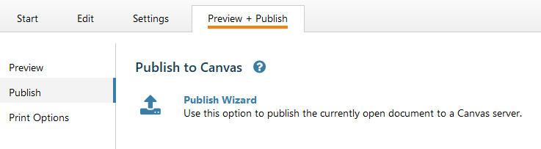

The *Publish Wizard* dialog box opens.

1. Leave **the Publish to single course** radio button selected.
2. Click the arrow on the **Canvas Server** field and select the **add new server** option.

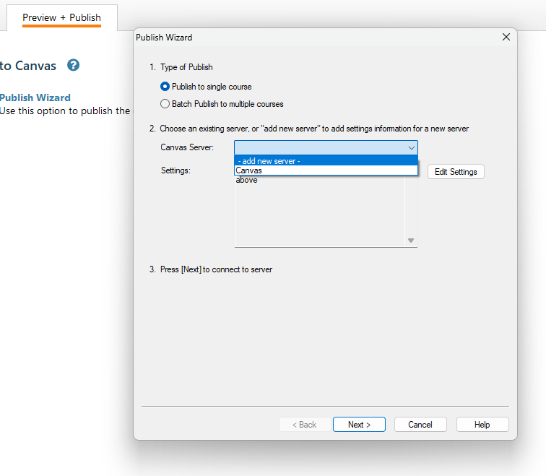

The *Add New Server Settings* dialog box appears.

1. Click the **No, I want to enter the server settings manually** radio button and click **Next**.

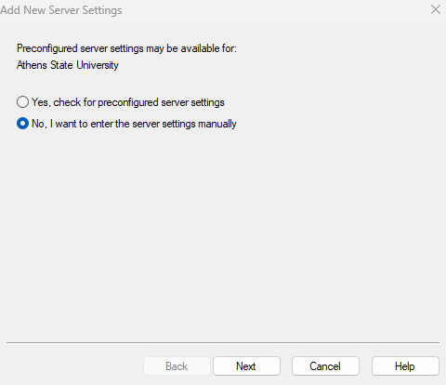

The *Canvas Server Settings* dialog box opens.

1. Follow the instructions on the box to set the connection to Canvas and click **OK** (you will only have to complete this step the first time you use Respondus).
   * In no. 5, do not enter the password you normally use to access Canvas. Contact the Canvas Admin for the password to enter in this field.

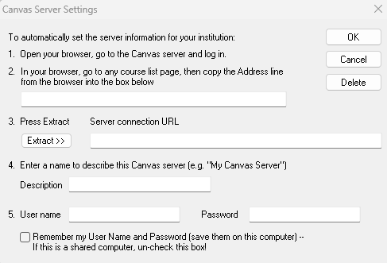

1. Click **Next** to connect to the server.
2. Accept the default entries on the next window and click **Next**.
3. Select the course in which you want to publish the quiz and click **Next**.
   * Note: you must be enrolled in the Canvas course as an instructor, TA, or designer for the course to appear on this screen. If it does not appear, check your enrollment status and also ensure that Respondus is up-to-date.

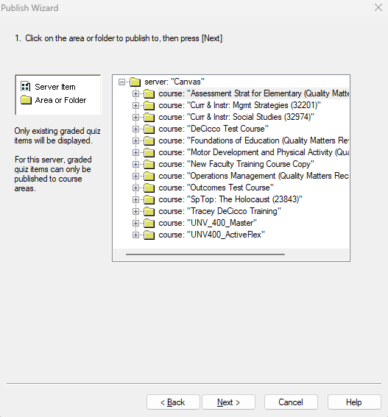

1. Click Finish. The quiz is uploaded to the course. You (or another designer) will need to go into the Canvas course and add it to the appropriate module.

